Reflective Conflict Guide for the APN
Reflect on a conflict situation that occurred recently or in the past. You may have been thinking about this situation for days, weeks, or months and you would like to have a greater depth of understanding about it. There are no right or wrong answers and no one method of resolving conflict that works in every situation. This tool was designed based on the reflective practice work of Johns (2009).
- What is the conflict issue?
- Who is affected?
- How are they affected?
- In what sphere of influence is the conflict occurring?
  - Patient and family
  - Nursing
  - Healthcare system
  - Within self
- What method of conflict resolution was selected or will be selected?
- What factors influenced my approach?
- Was the approach successful?
- What outcomes did I see manifested?
- Are other actions needed?
- I learned from this conflict situation (fill in response)
- I was surprised by (fill in response)

Table 1: Johns, C. (2004). Becoming a reflective practitioner (2nd ed.). Blackwell Publishing, Ltd.
Assertive Rating | Description | Title
10 | Being able to tread the “fine line” of pushing an issue and yielding | The controlled self
9 | Keeping self and other in adult mode | The managed self
8 | Being adept at counter-coercive tactics against more powerful others | The empowered self
7 | Being adept at interaction skills | The skill to assert self
6 | Taking the plunge | The resolve to assert self
5 | Creating the optimum conditions to maximize effectiveness | The scheming self
4 | Being able to make a good argument | The knowledge to assert self
3 | Understanding the boundaries of autonomy and authority in role | The right to assert self
2 | Having a focused vision for practice | The ethic to assert self
1 | Having felt the need to assert self | The motivational self

References
Johns, C. (2009). ​Becoming a reflective practitioner ​(3rd ed.). Wiley-Blackwell.

Additional Tools
Along with answering the questions on the reflective conflict guide, these three tools from Johns (2004) can help you gain insight into the conflict situation.
- Johns’ (2004) Assertiveness Action ladder
The assertive action ladder was devised by Christopher Johns to help nurses identify steps in becoming more assertive when advocating for themselves and patients. As you move from Step 1 to Step 10 you are becoming more assertive.
As you look at your conflict situation, how assertive were you feeling? Highlight the box.
- John’s Managing Conflict Grid
Research reveals that there is no one “best” way (or style) to manage conflict situations. The following graphic displays several possibilities and gives a description of the different management styles. Which style did you use in your conflict situation? Do you know which style is most “used” by nurses?
The styles of managing conflict
- Assertiveness:​ The degree to which individuals satisfy their own concerns.
- Co-operation​: The degree to which individuals attempt to satisfy the concerns of others.
- Accommodating: Essentially a cooperative interaction but one in which the practitioner is not​ assertive—is prepared to give up their own needs for the sake of maintaining a harmonious relationship. Apologetic.
- Avoidance​: Rationalization that attempts to challenge the behavior of another is futile.
- Collaboration​—Solves problems in a win-win situation. Concerned with needs of self and others.
- Competitive: Pursues his or her own needs to the exclusion of others (win-lose).
- Compromising: ​ Realizing that in conflict situations, every party cannot be satisfied. Accepts setting aside personal needs at times in preference to others to resolve conflict.
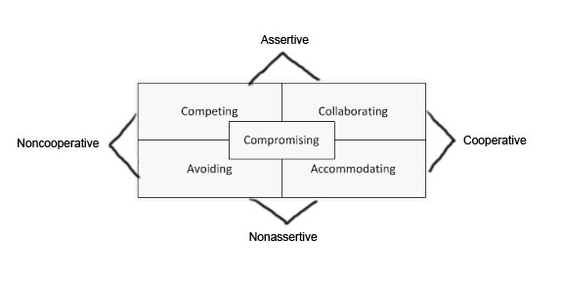
- Ethical Mapping (Johns, 2004)
If your conflict situation involved an ethical dilemma, use these questions to sort out the issues found within the conflict situation.

Factors to Consider when Completing Ethical Mapping | Answer to the Question Related to Identified Conflict Situation | Information Learned from This Exercise
What is the patient and family perspective?
Who has the authority to make the decision?
Who are the others involved in the conflict situation?
Is there a conflict in perspectives or values and, if so, how might this conflict be resolved?
What ethical principles are considered?
What is the nurse's perspective?
How is the decision made, considering the power relationships?
What is the organization's perspective?
Table 2: Johns, C. (2004). Becoming a reflective practitioner (2nd ed.) Blackwell Publishing, Ltd.

