Reflect on a conflict situation that occurred recently or in the past. This may be something that you have been thinking about over a few days, weeks, or months that you would like to have a greater depth of understanding. There are no right or wrong answers and no one method of resolving conflict that works in every situation. This tool was designed based on the reflective practice work of Johns (2009). In addition, you can use techniques you learned from the Interest Based Relational Approach from your learning material.

- What is the conflict issue?
- Who is affected?
- How are they affected?
- In what sphere of influence is the conflict occurring?
  - Patient and family
  - Nursing
  - Healthcare system
  - Within self

- What method of conflict resolution was selected or will be selected?
- What factors influenced my approach?
- Was the approach successful?
- What outcomes did I see manifested?

- Are other actions from this situation needed?

- I learned from this conflict situation (fill in response)
- I was surprised by (fill in response)
References
Johns, C. (2009). ​Becoming a Reflective Practitioner ​(3rd ed.). Oxford, England:
Wiley-Blackwell.

Along with answering the questions on the reflective conflict guide, these three tools from Johns (2004) can help you gain insight into the conflict situation.

Johns’ (2009) Assertiveness Action ladder
This assertive action ladder was devised by Christopher Johns to help nurses identify steps in becoming more assertive when advocating for themselves and patients. As you move from step 1 to step 10 you are becoming more assertive.
As you look at your conflict situation, how assertive were you feeling? Highlight the box.

10 | Being able to tread the “fine line” of pushing an issue and yielding | The controlled self
9 | Keeping self and other in adult mode | The managed self
8 | Being adept at counter-coercive tactics against more powerful others | The empowered self
7 | Being adept at interaction skills | The skill to assert self
6 | Taking the plunge | The resolve to assert self
5 | Creating the optimum conditions to maximize effectiveness | The scheming self
4 | Being able to make a good argument | The knowledge to assert self
3 | Understanding the boundaries of autonomy and authority in role | The right to assert self
2 | Having a focused vision for practice | The ethic to assert self
1 | Having felt the need to assert self | The motivational self

Johns, C. (2004). ​Becoming a Reflective Practitioner ​(2nd Ed.). Oxford, UK: Blackwell
Publishing, Ltd.
John’s Managing Conflict Grid
Research reveals that there is no one “best” way to manage conflict situations. This picture graphically displays several possibilities and gives a description of the different management styles. Which style did you use in your conflict situation? Do you know which style is most “used” by nurses?

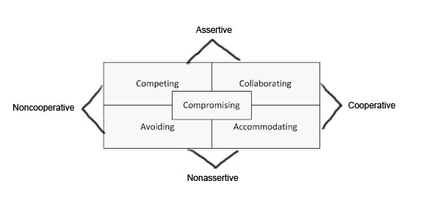

The styles of managing conflict

Assertiveness:​ the degree to which individuals satisfy their own concerns

Co-operation​: the degree to which individuals attempt to satisfy the concerns of others

Accommodating: Essentially a cooperative interaction but one in which the practitioner is not​ assertive - prepared to give up their own needs for the sake of maintaining a harmonious relationship. Apologetic

Avoidance​: Rationalization that attempts to challenge the behavior of another is futile.

Collaboration​ – Solve problems in a win-win situation. Concerned with needs of self and others

Competitive: ​ Pursues his or her own needs at the exclusion of others (win-lose)

Compromising: ​ Realizing that in conflict situations, every party cannot be satisfied. Accepting at times to set aside personal needs in preference to others to resolve conflict.
Ethical Mapping (Johns, 2004)
If your conflict situation involved an ethical dilemma, use this map to sort out the issues found within the conflict situation. The map has nine boxes with questions and you can write your answers in each box. What information did you learn after completing this map?

Patient and family perspective | Who has the authority to  make the decision | Other involved in conflict situation position
Is there conflict in values? How might the conflict be resolved? | The dilemma: | Ethical principles? What would be the right or best decision?
The person involved in the conflict perspective or the  nurses’ perspective | How the decision actually made? (power relationships) | The organization’s perspective?

Johns, C. (2004). ​Becoming a Reflective Practitioner ​(2nd Ed.). Oxford, UK: Blackwell
Publishing, Ltd.

