AGNP/FNP Final Case Study

Overview

Think about all you have learned in regard to taking care of adult patients and consider the case presentation that follows. Answer all the questions completely and use peer-reviewed evidence to support your answers.

Visit 1
Mrs. Johnson is a 60-year-old female who presents to your office with right shoulder pain. She just moved to the area with her husband a few months ago. She is coming to see you today with a two-week history of nasal congestion, fever, some cough, and a sore throat. She reports that she initially felt like she had a cold, thought she was getting better, then got worse again. At the onset of her illness, she describes clear nasal drainage, which has now turned more purulent. She does endorse headaches and some pressure around her eyes. She does not have any of her medical records, but states that she does not have any medical conditions other than some chronic aching in her shoulders.
- Based on the clinical manifestations she is demonstrating, identify three different disorders or conditions that could be causing her symptoms. Briefly explain your rationale for each.
- At the onset of her illness, were her symptoms and underlying pathophysiology most likely bacterial or viral in nature? Explain your rationale.
- At the time of the office visit, were her symptoms and underlying pathophysiology most likely bacterial or viral in nature? Explain your rationale.
Based on the length of her illness, the presence of fever, and the worsening trajectory of illness, Mrs. Johnson is diagnosed with acute bacterial rhinosinusitis and started on antimicrobial therapy.
- Explain why secondary bacterial infections may commonly follow viral infections in the respiratory tract of older adult patients.
- Would this same therapy have helped return Mrs. Johnson to a more homeostatic state if started at the onset of her illness? Explain why or why not.

Visit 2
Mrs. Johnson has returned for another visit. She reports that she has recovered from her sinus infection and feels much better. However, today, she states that she is having increasing right shoulder pain over the past couple of weeks. She explains that her shoulders have “always bothered” her because she worked in a factory moving boxes for years. She states that she uses naproxen, “prescription strength,” and that usually does the trick when her pain flares up, but she is out and would like a refill.
- In a patient Mrs. Johnson’s age, what conditions or disorders could cause shoulder pain as she describes? Identify three and explain your rationale.
- Explain how a medication like naproxen may interrupt the pathophysiology of one of those conditions and help reduce pain. In other words, how does the use of that medication return Mrs. Johnson to a more homeostatic state?
On exam, you note that her right shoulder is tender to palpate, and she has limited range of motion. She smells of BenGay but, otherwise, she seems healthy. There still have not been any medical records available for review. The area is edematous, and when asked, she does agree that her arm seems swollen. She denies any falls but remembers that she lost her balance and fell backward into her recliner a few days ago “kind of hard” but she caught herself when she grabbed for the coffee table. Otherwise, she does not recall any injuries. You decide to send Mrs. Johnson for an x-ray and she is in the waiting room until you get the results back.
The following radiograph (image 1) is what is sent to you via teleradiology.
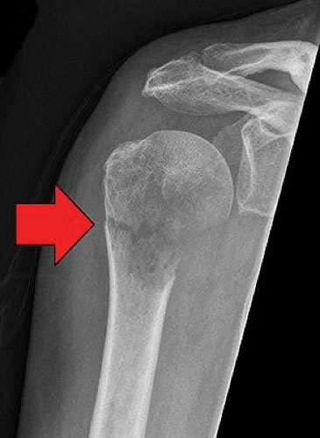
- The x-ray indicates a pathological fracture of her humerus. What is a pathological fracture?
- What can cause a pathological fracture? Be specific.
- Assuming you had access to Mrs. Johnson’s medical records, what history or risk factors would you be looking for that could predispose her to an injury of this sort.
- Identify three interventions that can promote healing of a pathological fracture. Explain how these interventions will help return Mrs. Johnson to a more homeostatic state.
During your exam of her shoulder, you notice a suspicious looking skin growth on her back (image 2). Mrs. Johnson states that it has been there a long time, but does seem to be getting bigger. She reports that it occasionally bleeds and now seems to be darker than it was before.
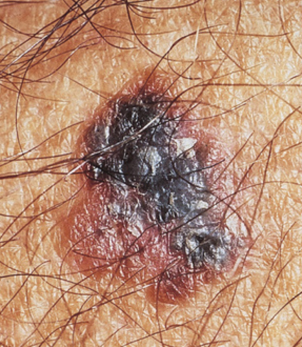
- List the signs of possible malignant changes in a skin lesion. Which of these signs is Mrs. Johnson exhibiting?
- Based on the description and appearance, which type of lesion are you most suspicious for? In your answer, discuss the characteristics of the typical lesion of squamous cell carcinoma, melanoma, and Kaposi sarcoma.
- List the four warning signs of skin cancer. Which of these is Mrs. Johnson exhibiting?

