Making a Video in ZOOM

Zoom Tutorial

Table of Contents
- Welcome to Zoom
- Getting Started: Zoom User Guide
- Logging into Zoom
- Download the Zoom App
- Joining a Meeting
  - Connecting Your Audio
  - Video
- Recording Videos with Zoom
  - Creating Zoom Videos 1—Setup
  - Creating Zoom Videos 2—Making a Recording
  - Creating Zoom Videos 3—Accessing Your Recording
- Live Session Best Practices
  - Hardware
  - Software
  - Webcams: Best Practices
  - Audio: Best Practices
  - Preparation
- Getting Your Zoom Meeting URL (Using Free Version)
- Starting a Zoom Live Session
  - Screen Sharing

Welcome to Zoom
This guide will help you learn and master the Zoom synchronous software tool for your online live sessions. This software is easy to use, intuitive, and presents the user and instructor an opportunity to create a dynamic learning environment. The Zoom company also has a rich set of training materials and resources for both students and instructors.
Training materials at the Zoom Help Center.
Before you begin using Zoom, there are some basic resources that you should download or view. These are documents and locations of materials that should always have at your fingertips:

Getting Started: Zoom User Guide
- Read Getting Started on Windows and Mac.
- Watch Recorded Training Sessions
- Join Weekly Zoom Meetings and Live Training Webinars
- Join a test Meeting

Logging into Zoom
To sign-in, simply go to Zoom and select Login. From there you can Login using Google, Facebook, or your already existing Zoom account. You can also login using your company SSO (single-sign-on)
For Regis users, go to Regis Sign in.

Download the Zoom App
Select the download footer link on Zoom or directly from the Zoom support download page.
- For iOS, visit the Apple App Store and search zoom.
- For Android, visit Google Play and search zoom.

Joining a Meeting
Your instructor will post meeting information in your course under Live Sessions (Communications Tab) or through the Course Announcements. Select your instructor's posted Zoom link to launch a meeting (assuming you have already downloaded the Zoom app). Then select Zoom Meetings and Open Link to join the meeting. Watch Join a Meeting to see how to join a Zoom meeting.

Connecting Your Audio
- Testing Computer or Devise Audio
- Joining a Meeting by Phone
- Audio Echo in a Meeting
- Using Telephone Call-Out
- 3rd Party Audio Conference
- Can I use a Bluetooth Headset?

Video
- My Video/Camera isn't Working
- How do I test my Video?
- How do I Change the Video Layout?
- Camera Video is Unavailable on a Mac running 10.7
- Do I have to have a webcam to join Zoom?

Recording Videos with Zoom
The following Regis College video tutorial series will help you create your own Zoom video recordings. As long as you have a microphone, a webcam, and a quiet working environment, you should be able to create dynamic presentations and personal videos in minutes.
Please note that at this time, only students in the MSW program have Zoom Pro accounts.

Creating Zoom Videos 1—Setup (8:23 minutes)

Creating Zoom Videos 1—Setup Video Transcript

Creating Zoom Videos 2—Making a Recording (5:12 minutes)

Creating Zoom Videos 2—Making a Recording Video Transcript

Creating Zoom Videos 3—Accessing Your Recording (2:36 minutes)
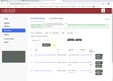
Creating Zoom Videos 3—Accessing Your Recording Video Transcript

Live Session Best Practices
Listed below are some ways to help improve your live synchronous sessions with your instructor and peers and to help you engage in a professional and positive learning environment:

Hardware
Purchase a USB headset microphone. These are relatively inexpensive at your local Best Buy or electronics store. They work better than a standard microphone and speaker because the microphone and speakers are isolated from each other. Plus, they give you a hands-free experience. A very popular one is shown below:
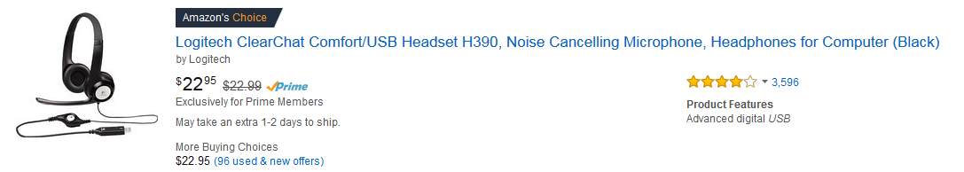
Connect all your equipment and test it in advance. As soon as you enter your live session, be sure to test your audio and video capabilities. If you choose to connect your hardware after you launch your live session software, the program may not detect it.

Software
Most live session programs are dependent on Adobe Flash, Java, or a combination of both. Some will demand increased access to your computer or will require you to download a plug-in to make it work.
As a common rule, update the following software before you start:
- Adobe Flash Player
- Java
- How to Enable Flash Plugin for Specific Web Sites Only in Safari for Mac OS X

Webcams: Best Practices
Light: Make sure there’s lots of light in front and above you and as little as possible behind you. A lot of light behind you (window, lamp, etc.) will darken your image and make you look like you are in a witness protection program.
Color: Avoid fluorescent colors, checkers, and stripes. These can confuse webcams and make odd shapes on screen.
Be Mindful of Your Surroundings: Everything can be seen behind you—even things you never thought people could see! Alert people who might be in the area that you need privacy.

Audio: Best Practices
Headsets are key: Headsets cancel out background noise and ensure easier connectivity. They also allow for better quality sound.
Why Am I Getting an Echo? This is due to you or someone in your session having their speakers on while their microphone is on at the same time. To fix this problem, the instructor may choose to mute the speakers for the whole group.
Read Audio Echo in a Meeting.

Preparation
Review your Course Announcements and Live Session area. Upcoming live session information, session focus and/or agendas will be posted to help students prepare for what will be discussed.

Getting Your Zoom Meeting URL (Using Free Version)
As a student, you can host a meeting by using the free version of Zoom, which allows up to 45 minutes. The first thing you’ll need to do before you run a Zoom meeting is obtain your own Zoom meeting URL and to distribute it to your attendees.
Log in to your Zoom main profile page:
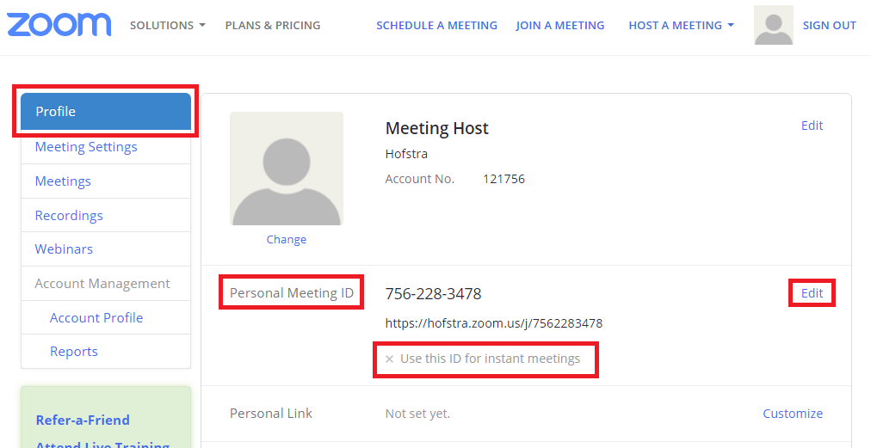
- Select the Profile tab on the left-side panel.
- Look for the Personal Meeting ID heading. This URL will serve as your live session meeting URL for as long as you wish. While you can still make separate meeting URLs for scheduled Zoom sessions, this Personal Meeting URL should fulfill all your needs.
- Before you can use this Personal Meeting ID with your attendees, you first have to enable it for instant meetings. Select Edit on the right-hand side and select Use Personal Meeting ID for instant meetings.
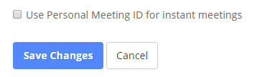
The Personal Meeting ID URL is now ready to be distributed to attendees. You’ll notice that a green arrow now appears next to the phrase Use this ID for instant meetings.
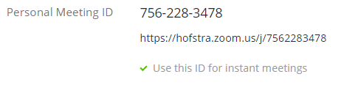
Some users prefer to make a personalized meeting link, especially if they want others to recognize that the meeting URL is for a specific purpose. Select Customize to the right of the Personal Link heading and choose a URL that you prefer. This link can also be used for any meeting.
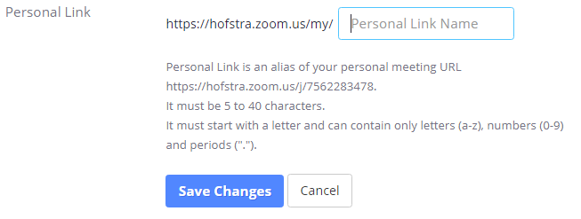

Starting a Zoom Live Session (Use for Student Collaboration with Free Version)
The best way to start a Zoom session is simply through your Personal Meeting Room URL. At any time, copy and paste the URL into your browser and it will launch from your downloaded Zoom app. Be sure, however, that you have already logged into your Zoom account via your institution’s Zoom web address. This will ensure you login as a Host instead of as a standard attendee.
The instructions below are general and are mostly from the perspective of a scheduled meeting, rather than a Personal Meeting Room URL:
- How do I host a Video Meeting?
- How do I Invite others to join a Meeting?
- How do I join a Meeting?
- How do I start or join a Scheduled Meeting as the host?

Screen Sharing
- How do I Share my Screen?
- Sharing a whiteboard
- Black Screen During Screen Sharing
- Sharing Computer Sound During Screen Sharing
- Screen Share a Camera Input
- How do I Start a Screen Share Meeting?
- Optimizing a Shared Video Clip in Full Screen
- Using Annotation tools on a shared screen or Whiteboard
- Screen Sharing a PowerPoint Presentation
- Screen Share a Keynote Presentation
- Full-screen when screen-sharing?
- Switching Windows During Screen Sharing
- Request or Give Remote Control

