Aim Statement Worksheet

An aim statement is the answer to the first question in the Model for Improvement, “What are we trying to accomplish?” Effective aim statements delineate clear, specific plans for the work ahead.
Use the prompts below to write an effective aim statement. Then use the checklist to double-check your work.
What? What’s the problem or opportunity? Make sure it relates to a fundamental customer need.
Example: Increase the percent of children who receive a Health Needs Assessment.

How much? By how much will you improve? Or “how good” do you want to get?
Example: 95% of children who should receive a Health Needs Assessment will receive one.

By when? What is the date by which you will achieve the level of improvement you’ve set out to accomplish?
Example: January 31, 2020

For whom? Who is the customer or population who will benefit from the improvement?
Example: Children under the age of 12 who have an initial referral to Child Protective Services
Where? What are the boundaries of the process or system you’re trying to improve? Where does it begin and end?
Example: In Middlesex County

Complete aim statement (submit the contents of the complete statement to Discussion 2.2):
Example: By January 31, 2020, of children under the age of 12 for whom a Health Needs Assessment is recommended, 95% will receive the assessment in Middlesex County.

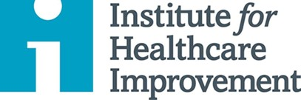
Copyright © 2019 Institute for Healthcare Improvement. All rights reserved. Individuals may photocopy these materials for educational, not-for- profit uses, provided that the contents are not altered in any way and that proper attribution is given to IHI as the source of the content. These materials may not be reproduced for commercial, for-profit use in any form or by any means, or republished under any circumstances, without the written permission of the Institute for Healthcare Improvement

